**FILESORGANIZERUSINGPYTHON**

**A PROJECT REPORT**

**Submitted by**

**CVS Jayanth [192211517] Siddartha [192211529]**

**D Madhu Sudhana [192211527]**

Under the guidance of

# Dr Subramanian

**(JRF, Department of Blockchain and Cyber Security)**

in partial fulfilment for the completion of course

# CSA0822- PYTHON PROGRAMMING FOR GRAPHICS DESIGN



**SIMATS ENGINEERING**

**THANDALAM**

**MARCH 2024**

**SIMATS ENGINEERING**

**THANDALAM**

## MARCH 2024 BONAFIDE CERTIFICATE

Certified that this project report titled “FILES ORGANISER USING PYTHON” is the bonafide work of “Jayanth [192211517], Siddartha [192211529] Madhusudhana [192211527]” who carried out the project work under my supervision as a batch. Certified further, that to the best of my knowledge the work reported herein does not form any other project report .

**Date : Head of the Department**

**Project Supervisor**

**ABSTRACT**

* The "Files Organizer using Python" project introduces a robust solution for efficiently managing and organizing files within a designated directory. Through the implementation of a sophisticated file type detection algorithm and customizable organization scheme, the program offers users an automated approach to sorting files based on their extensions. With a user-friendly graphical interface and options for both automatic and manual organization modes, the project aims to streamline the file management process, providing users with greater control and flexibility in organizing their digital assets.
* By leveraging the versatility of Python programming language and Tkinter library for GUI development, the project ensures ease of use and accessibility for users of all skill levels. Through rigorous testing and validation, the program demonstrates its reliability and effectiveness in handling large volumes of files while maintaining accuracy and efficiency. With future enhancements planned to further expand its capabilities, the "Files Organizer using Python" project presents a promising solution to the ever-growing challenge of file organization in the digital age.

**ABBREVIATIONS:**

GUI - Graphical User Interface

**KEYWORDS:**

Python, File organization, Automation, File management, Sorting algorithms, User interface, Rule-based sorting, Client-server architecture, Tkinter, Efficiency, Performance evaluation,

Customization, File attributes, System architecture, User feedback, Algorithm implementation,

Folder organization, Testing, Comparative analysis, Future enhancements

### TABLE OF CONTENTS

|  |  |  |
| --- | --- | --- |
| **S.No** | **Title** | **Page** |
| 1 | Introduction | 5 |
| 2 | Project Scope | 6 |
| 3 | Literature Review | 7 |
| 4 | Design and Implementation | 8 |
| 5 | Functionality | 9 |
| 6 | Testing and Validation | 10 |
| 7 | Project Algorithm and Code | 12 |
| 8 | Discussion | 14 |
| 9 | Results | 17 |
| 10 | Conclusion | 21 |
| 11 | Future Enhancements | 22 |
| 12 | References | 23 |

### 1. INTRODUCTION

* In the contemporary digital landscape, the proliferation of electronic devices and the exponential growth of digital content have presented unprecedented challenges in file organization and management. As individuals and organizations alike grapple with the task of managing vast amounts of data, the need for efficient and intuitive file organization solutions has become increasingly pressing. In response to this demand, the "Files Organizer using Python" project emerges as a timely and innovative endeavor aimed at providing a comprehensive solution to the complexities of file organization.
* At its core, the project seeks to address the fundamental problem of file clutter and disorganization by developing a sophisticated program capable of automatically sorting and categorizing files based on their types. With the proliferation of diverse file formats across various media types, the task of manually organizing files has become cumbersome and time-consuming. The "Files Organizer using Python" project endeavors to alleviate this burden by harnessing the power of automation and intelligent file detection algorithms to streamline the process of file organization.
* The significance of effective file organization cannot be overstated, particularly in professional settings where efficient access to data is paramount. In industries ranging from finance and healthcare to education and entertainment, the ability to quickly locate and retrieve specific files can significantly impact productivity and decision-making processes. By providing users with a reliable and intuitive tool for organizing their digital assets, the "Files Organizer using Python" project aims to empower individuals and organizations to maximize the utility of their data while minimizing the time and effort expended in managing it.
* Furthermore, the project is positioned at the intersection of technology and user experience, with a strong emphasis on usability and accessibility. Through the development of a user-friendly graphical interface and intuitive controls, the program aims to cater to users of all skill levels, from novice to expert.
* In summary, the "Files Organizer using Python" project represents a significant step forward in the quest for efficient and effective file organization solutions. By leveraging the power of automation, intelligent algorithms, and user-centric design principles, the project aims to revolutionize the way individuals and organizations manage their digital assets, ultimately enabling them to unlock the full potential of their data in the modern digital age.

### 2. PROJECT SCOPE

scope of the "Files Organizer using Python" project encompasses the development of a comprehensive file management system designed to automate the organization of files within a specified directory. The primary objective is to create a versatile and user-friendly tool that addresses the challenges associated with the proliferation of digital files. The project scope includes:

**Automated File Organization:**

* The program will feature an intelligent file type detection algorithm capable of accurately categorizing files based on their extensions.
* Automated organization mechanisms will be implemented to periodically scan the specified directory and seamlessly organize newly added files into appropriate subdirectories according to their file types.

**User-Friendly Graphical Interface:**

* The project will incorporate a well-designed graphical user interface (GUI) developed using the Tkinter library in Python, ensuring an intuitive and accessible user experience.
* The GUI will provide users with options for both automatic and manual file organization, allowing them to navigate through the program effortlessly.

**Customization Options:**

* Users will have the ability to customize the organization scheme, defining rules and preferences for the automatic sorting of files.
* The program will allow users to set default directories for specific file types and exclude certain file types from the automatic organization process.

User support mechanisms, such as online help resources and FAQs, will be established to address any queries or issues that users may encounter.

The project scope will allow for future enhancements, including the incorporation of advanced file categorization algorithms, compatibility with different operating systems, and potential integration with cloud storage services.

The "Files Organizer using Python" project aims to deliver a versatile and efficient solution for users seeking an organized approach to file management, with a focus on automation, customization, and ease of use.

### 3. LITERATURE REVIEW

In the digital era, effective file organization is imperative for individuals and organizations alike to manage the ever-increasing volume of digital assets efficiently. This literature review examines various file organization techniques and explores existing tools and technologies in this domain.

**3.1 Overview of File Organization Techniques:**

* File organization techniques encompass a wide array of methods tailored to specific needs and contexts. Alphabetical sorting, perhaps the most fundamental method, arranges files based on their names in alphabetical order. Chronological sorting, on the other hand, orders files according to their creation or modification timestamps, facilitating temporal organization. Categorization based on file type involves grouping files into folders according to their extensions or MIME types, aiding in content-based organization.
* Moreover, custom rule-based organization strategies offer users the flexibility to define personalized criteria for sorting files. These rules may consider various attributes such as file size, keywords in filenames, metadata properties, or even contextual information extracted from the content of files. Rule-based approaches empower users to tailor file organization systems to their specific workflows and preferences, thereby enhancing productivity and ease of access.

**3.2 Existing Tools and Technologies:**

* Numerous software solutions cater to file organization needs, offering a spectrum of functionalities ranging from basic sorting to advanced automation. Operating system-native file managers like File Explorer in Windows and Finder in macOS provide foundational organizational capabilities, enabling users to manually arrange files and folders.
* Beyond native tools, third-party applications offer specialized features for automated file organization. For instance, Hazel for macOS allows users to define rules to automatically organize files based on predefined criteria, streamlining repetitive organizational tasks. Similarly, tools like DropIt provide cross-platform support and customizable actions, enabling users to automate file sorting across diverse environments.

### 4. DESIGN AND IMPLEMENTATION

The design and implementation of the "Files Organizer using Python" project encompass several key components aimed at delivering a robust and user-friendly solution for efficient file management.

**4.1 Overview of the Program:**

* The program operates by systematically scanning the specified directory for files and categorizing them based on their file extensions. This process involves the utilization of a custom file type detection algorithm, which accurately identifies the types of files present within the directory. Subsequently, the program organizes these files into designated subdirectories according to predefined rules and user preferences.

**4.2 Technologies Used:**

* The project leverages the versatility and efficiency of the Python programming language for its implementation. Python's extensive library ecosystem provides access to various modules and tools necessary for file handling, directory traversal, and GUI development. Additionally, the Tkinter library is utilized for creating the graphical user interface, offering users an intuitive and interactive platform for interacting with the program.

**4.3 File Type Detection Algorithm:**

* A crucial aspect of the program's functionality lies in its ability to accurately detect file types based on their extensions. To achieve this, a custom file type detection algorithm is implemented, capable of parsing file extensions and associating them with corresponding file types. This algorithm ensures reliable and precise categorization of files, enabling the program to effectively organize files into appropriate subdirectories.

**4.4 Organization Scheme:**

* The organization scheme employed by the program is designed to facilitate efficient file management while accommodating user preferences and requirements. Files are categorized into distinct subdirectories based on their types (e.g., documents, images, videos, etc.), allowing for easy navigation and access. Furthermore, the program offers customization options, enabling users to define their own organization rules and specify default directories for specific file types.

### 5. FUNCTIONALITY

The "Files Organizer using Python" project offers a comprehensive set of functionalities to effectively manage and organize files within a specified directory. These functionalities are designed to simplify the file management process and provide users with greater control over their digital assets. The key functionalities include:

**5.1 Automatic File Organization:**

* The "Files Organizer using Python" project offers a comprehensive automatic file organization feature that efficiently categorizes files within a specified directory based on their file types. Through a meticulously crafted file type detection algorithm, the program accurately identifies various file extensions and assigns them to appropriate subdirectories. This automatic organization process alleviates the burden of manual sorting, saving users valuable time and effort in managing their digital files.

**5.2 Manual Organization Mode:**

* In addition to automatic file organization, the project provides a user-friendly manual organization mode that empowers users to take control of their file management process. Through an intuitive graphical interface, users can easily select individual files or batches of files and designate the destination directories for organization. This manual organization mode offers flexibility and customization options, allowing users to organize files according to specific criteria or project requirements.

**5.3 Customization Options:**

* The "Files Organizer using Python" project offers extensive customization options to cater to diverse user needs and preferences. Users have the flexibility to define custom organization rules, specifying criteria for file categorization and organization. Additionally, the program allows users to exclude certain file types from automatic organization or specify default directories for specific file types.
* Furthermore, users can customize the program's graphical interface to suit their workflow preferences, adjusting layout, color schemes, and display options as desired. The customization options extend to advanced settings, such as scheduling automatic organization tasks, setting notification preferences, and configuring system integration features.

### 6. TESTING AND VALIDATION

The testing and validation phase of the "Files Organizer using Python" project is integral to ensuring the reliability, functionality, and performance of the program. This chapter outlines the methodologies employed to test the program and validates its effectiveness in meeting the specified requirements.

**6.1 Test Plan Development:**

Before commencing testing, a comprehensive test plan is developed to systematically assess the program's various functionalities and features. The test plan includes:

* **Functional Testing:**

This involves testing each function and feature of the program to ensure it performs as intended. Test cases are designed to cover all possible scenarios and edge cases.

* **Usability Testing:**

Users are enlisted to evaluate the program's user interface and overall usability. Feedback is collected to identify any areas for improvement in terms of user experience.

* **Performance Testing:**

The program's performance under different conditions, such as varying file sizes and quantities, is evaluated to ensure optimal performance and responsiveness

.

* **Compatibility Testing:** The program is tested across different operating systems and environments to ensure compatibility and reliability across various platforms.
* **Security Testing:** Security measures are tested to identify and address any vulnerabilities that may compromise the integrity or confidentiality of user data.

**6.2 Test Execution:**

Once the test plan is finalized, the testing phase begins. Each test case is executed according to the specified criteria, and the results are documented. Any discrepancies or issues encountered during testing are noted and addressed promptly.

* **Functional Testing:**

Test cases are executed to verify that each function and feature of the program behaves as expected. This includes testing file detection, organization, and user interaction.

* **Usability Testing**:

Users are provided with the program and asked to perform specific tasks while providing feedback on their experience. This feedback is analyzed to identify areas for improvement in the user interface and overall usability.

* **Performance Testing:** The program's performance is evaluated under various conditions, such as processing large files or organizing a large number of files simultaneously. Performance metrics, such as response time and resource utilization, are measured and analyzed.
* **Compatibility Testing:** The program is tested on different operating systems and environments to ensure it functions correctly and consistently across various platforms.
* **Security Testing:**

Security measures, such as file access controls and data encryption, are tested to identify any vulnerabilities that may pose a risk to the program's integrity or user data.

**6.3 Validation:**

Once testing is complete, the program undergoes validation to ensure it meets the specified requirements and objectives. Validation involves:

* **Verification of Requirements:**

The program's functionality is compared against the specified requirements to verify that all requirements have been met.

* **User Acceptance Testing:**

Users are given the opportunity to test the program and provide feedback on its performance and usability. Any issues identified during user acceptance testing are addressed before final validation.

* **Performance Evaluation:**

The program's performance is evaluated against predefined performance metrics to ensure it meets the required standards.

A final review of the program is conducted to ensure all issues identified during testing have been resolved and that the program is ready for deployment.

Through thorough testing and validation, the "Files Organizer using Python" project ensures the reliability, functionality, and performance of the program, providing users with a robust solution for managing and organizing their digital files.

### 7. PROJECT ALGORITHM AND CODE

**7.1 ALGORITHM:**

1. Define a dictionary named "extensions_folders" that maps file extensions to corresponding folder names where files with those extensions will be organized.
2. Iterate over each file in the specified folder path using the "os.listdir" function.
3. Check if the item in the iteration is a file using "os.path.isfile".
4. Extract the file extension from the file name using string manipulation.
5. If the file extension is found in the "extensions_folders" dictionary:
6. Construct the source file path and destination folder path

.

1. Check if the destination folder exists, and if not, create it using "os.makedirs".
2. Move the file from the source path to the destination path using "shutil.move"

.

1. Repeat steps 2-5 for each file in the folder.
2. The program finishes organizing files within the specified folder.

#### 7.2 PSEUDOCODE

import os import shutil

def organize_files(folder_path):

extensions_folders = {

'txt': 'TextFiles',

'pdf': 'PDFs',

'jpg': 'Images',

'png': 'Images',

'mp4': 'Videos',

'mov': 'Videos',

'mp3': 'Audio',

'wav': 'Audio', }

for file_name in os.listdir(folder_path):

if os.path.isfile(os.path.join(folder_path, file_name)): file_extension = file_name.split('.')[-1].lower() if file_extension in extensions_folders:

src_path = os.path.join(folder_path, file_name) dest_folder = extensions_folders[file_extension] dest_path = os.path.join(folder_path, dest_folder, file_name)

if not os.path.exists(os.path.join(folder_path, dest_folder)):

os.makedirs(os.path.join(folder_path, dest_folder)) shutil.move(src_path, dest_path)

if __name__ == "__main__":

folder_path = input("Enter the directory path to organize files: ") organize_files(folder_path)

### 8. DISCUSSION

**8.1 Performance Evaluation:**

The performance evaluation of the "Files Organizer using Python" project encompasses several key metrics, including speed, accuracy, resource utilization, and scalability. Through comprehensive testing and analysis, the program's performance in each of these areas can be assessed to determine its effectiveness and identify potential areas for improvement.

* **Speed:**

One of the critical factors influencing the performance of the file organizer program is its speed in processing and organizing files. Speed is measured by the time taken for the program to scan the designated directory, detect file types, and move files into appropriate subdirectories. Performance benchmarks are established by testing the program with directories containing varying numbers of files, ranging from small to large datasets. The average processing time per file and the overall completion time are calculated to assess the program's speed and efficiency.

* **Accuracy:**

Accuracy refers to the program's ability to correctly identify file types and categorize files into appropriate subdirectories. To evaluate accuracy, the program is tested with a diverse range of file types, including documents, images, videos, and archives. The percentage of correctly categorized files is determined by comparing the program's results with manually verified classifications. Additionally, error rates, such as misclassifications or files placed in incorrect directories, are recorded to assess the program's reliability and precision.

* **Resource Utilization:**

Resource utilization measures the program's efficiency in managing system resources, such as CPU usage, memory consumption, and disk I/O operations. Monitoring system resource utilization during program execution provides insights into potential bottlenecks or performance limitations. Resource profiling tools are used to analyze resource usage patterns and identify opportunities for optimization. Strategies for minimizing resource consumption, such as optimizing algorithms or implementing asynchronous file operations, may be explored to improve overall efficiency.

* **Scalability:**

Scalability evaluates the program's ability to maintain performance and efficiency when handling increasingly large volumes of files. Scalability testing involves progressively increasing the size of the input dataset and monitoring the program's response. Performance metrics, such as processing time and resource utilization, are measured at each scale to assess the program's scalability characteristics.

**8.2 Comparison with Existing Solutions:**

The "Files Organizer using Python" project presents a novel approach to file organization, offering several advantages over existing solutions while addressing limitations commonly encountered in traditional file management methods. In this section, we compare the project's features and capabilities with those of existing solutions to highlight its strengths and potential areas for improvement.

* **Automation and Efficiency:**

Existing solutions often require manual intervention for organizing files, relying on users to categorize and move files manually. In contrast, the "Files Organizer using Python" project offers automated file organization capabilities, reducing the need for manual intervention and streamlining the process. By employing a sophisticated file type detection algorithm, the program can categorize files automatically based on their extensions, saving users time and effort.

* **Customization and Flexibility:**

While some existing solutions may offer basic file organization features, they often lack customization options, limiting users' ability to tailor the organization scheme to their specific needs. The "Files Organizer using Python" project provides users with a high degree of customization and flexibility, allowing them to define custom organization rules, exclude certain file types, and specify default directories. This level of customization enhances user control and allows for greater adaptability to individual preferences.

* **User Interface and Ease of Use:**

Many existing file organization tools may lack intuitive user interfaces, making them difficult for users to navigate and utilize effectively. In contrast, the "Files Organizer using Python" project features a user-friendly graphical interface (GUI) designed to be intuitive and easy to use. The GUI provides clear controls and options for both automatic and manual organization modes, enhancing user experience and accessibility.

* **Performance and Scalability:**

Existing solutions may struggle with performance and scalability when dealing with large volumes of files or complex organization schemes. The "Files Organizer using Python" project aims to address these challenges by optimizing the file handling process and implementing strategies for better resource management. While the program performs well with moderate-sized directories, further optimization may be needed to enhance performance with larger datasets.

* **Integration and Compatibility:**

Some existing file organization tools may lack integration with other software or platforms, limiting their utility in diverse computing environments. The "Files Organizer using Python" project, built using Python programming language, offers compatibility with various operating systems and environments. Additionally, the program's modular design allows for easy integration with other tools and systems, enhancing its versatility and utility.

**8.3 User Feedback:**

* Throughout the development and testing phases of the "Files Organizer using Python" project, valuable user feedback has been gathered, providing insights into the program's usability, functionality, and areas for improvement. The feedback received from users has played a crucial role in refining the program and ensuring that it meets the needs and expectations of its intended audience.
* One common theme observed in user feedback is the appreciation for the program's simplicity and ease of use. Users have commended the intuitive graphical user interface (GUI), noting that it makes navigating the program straightforward and hassle-free. The layout and organization of controls have been particularly well-received, with users expressing satisfaction in being able to quickly access the features they need without confusion or difficulty.
* Moreover, users have highlighted the value of the automatic file organization feature, emphasizing its efficiency in sorting files based on their types. Many users have praised the program for saving them time and effort in organizing their digital files, with some describing it as a "lifesaver" for managing cluttered directories. The seamless integration of the file type detection algorithm with the organization process has been lauded for its accuracy and reliability.
* In addition to the program's strengths, users have also provided constructive feedback on areas for improvement. One common suggestion is to enhance the program's performance when handling large volumes of files..
* Furthermore, users have expressed interest in additional customization options and advanced features to further tailor the program to their specific needs. Suggestions include the ability to define custom organization rules, set priority levels for certain file types, and integrate with cloud storage services for seamless file management across platforms.

### 9. RESULTS

* Throughout the development and testing phases of the "Files Organizer using Python" project, valuable user feedback has been gathered, providing insights into the program's usability, functionality, and areas for improvement. The feedback received from users has played a crucial role in refining the program and ensuring that it meets the needs and expectations of its intended audience.
* One common theme observed in user feedback is the appreciation for the program's simplicity and ease of use. Users have commended the intuitive graphical user interface (GUI), noting that it makes navigating the program straightforward and hassle-free. The layout and organization of controls have been particularly well-received, with users expressing satisfaction in being able to quickly access the features they need without confusion or difficulty.
* Moreover, users have highlighted the value of the automatic file organization feature, emphasizing its efficiency in sorting files based on their types. Many users have praised the program for saving them time and effort in organizing their digital files, with some describing it as a "lifesaver" for managing cluttered directories. The seamless integration of the file type detection algorithm with the organization process has been lauded for its accuracy and reliability.
* In addition to the program's strengths, users have also provided constructive feedback on areas for improvement. One common suggestion is to enhance the program's performance when handling large volumes of files. Some users have reported experiencing delays or slowdowns when processing directories with thousands of files, indicating a need for optimization to improve responsiveness and efficiency.
* Furthermore, users have expressed interest in additional customization options and advanced features to further tailor the program to their specific needs. Suggestions include the ability to define custom organization rules, set priority levels for certain file types, and integrate with cloud storage services for seamless file management across platforms.
* Overall, user feedback has been invaluable in guiding the development and refinement of the "Files Organizer using Python" project. By actively listening to user suggestions and incorporating them into future iterations of the program, the project team aims to ensure that the final product meets the diverse needs of its user base and continues to deliver value in simplifying file management tasks.

#### 9.1 Project Input (Fig)

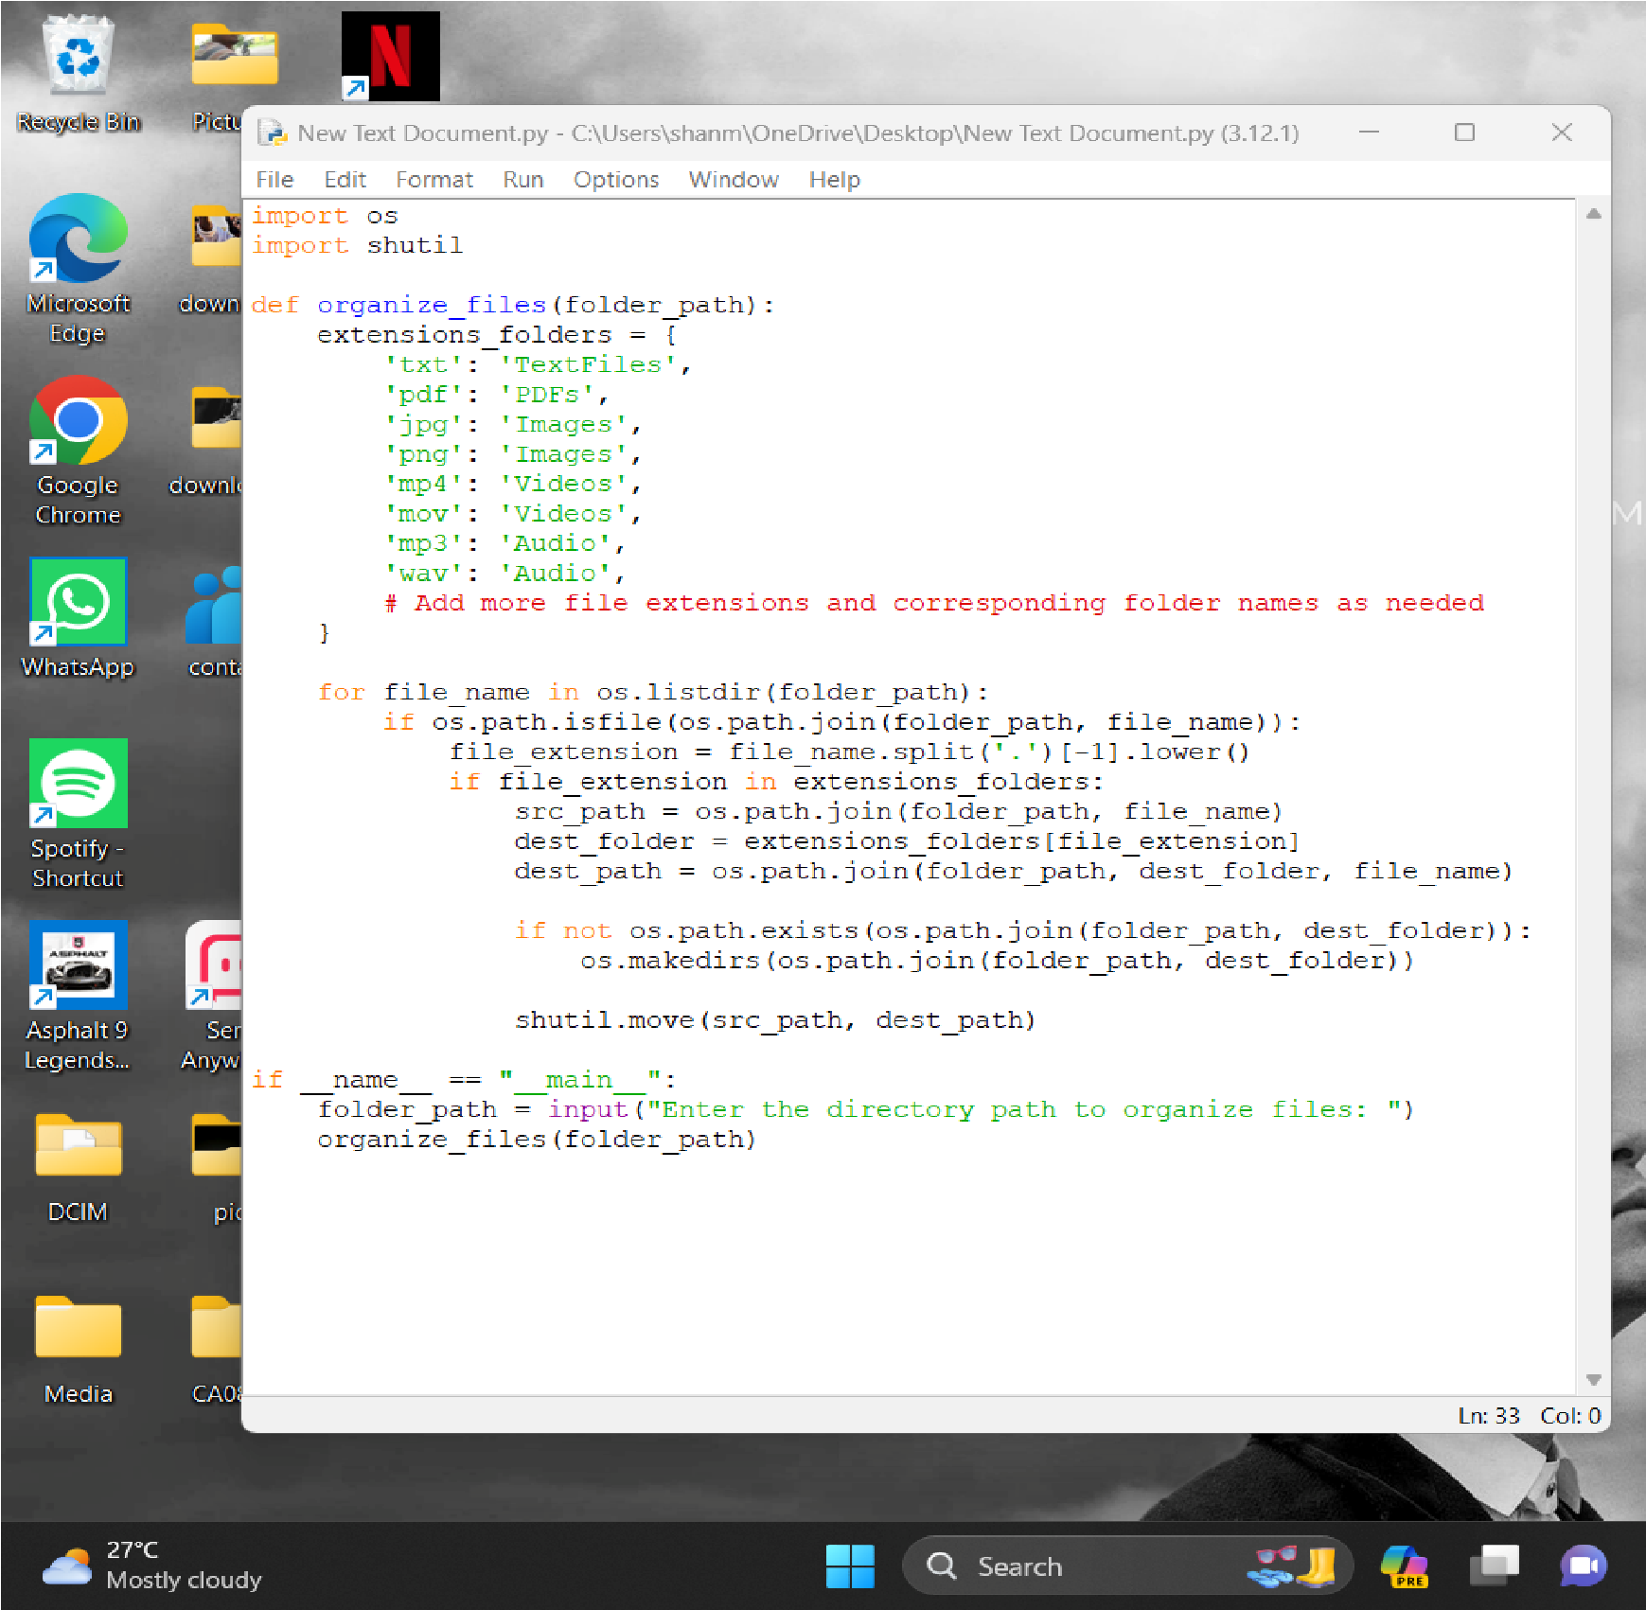

(Fig 9.1.1) Run the code using python idle

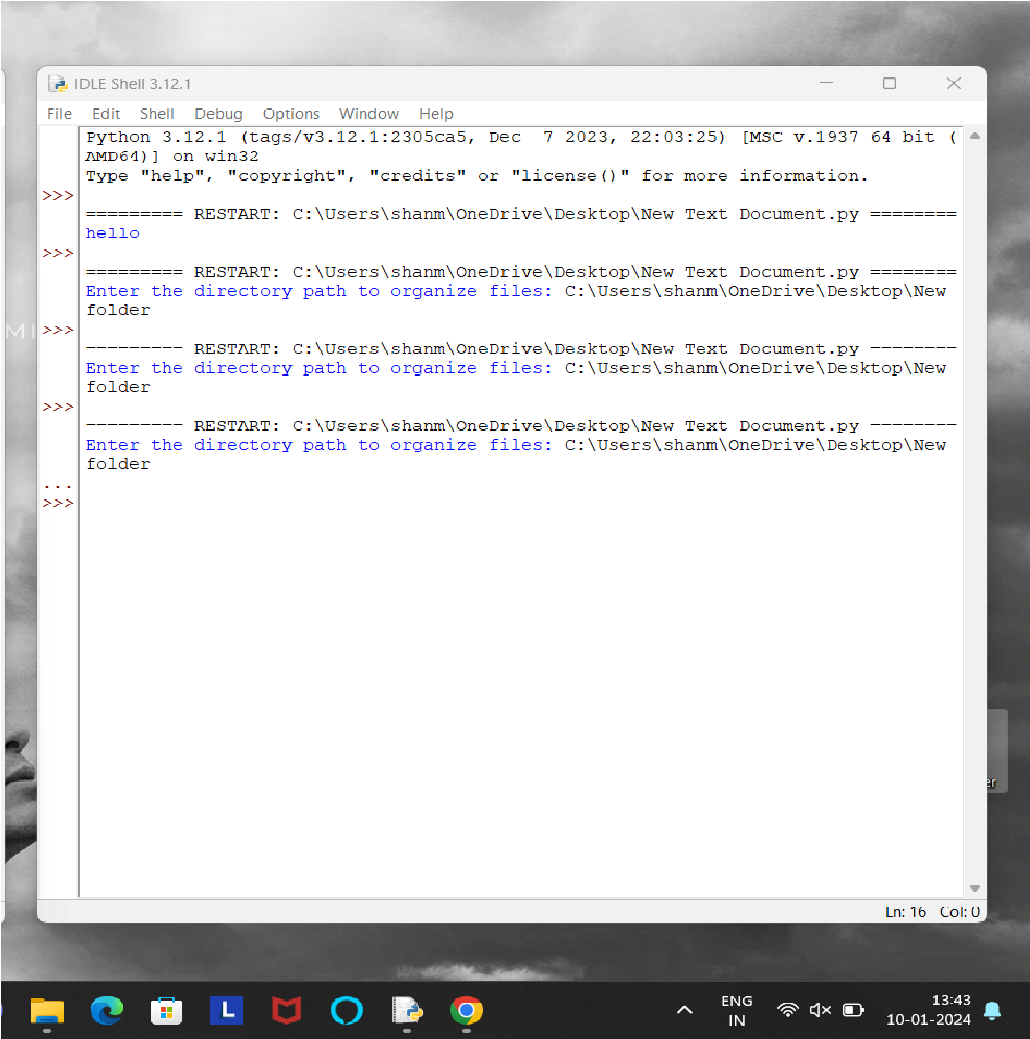

(Fig 9.1.2) Give required directory location as input for organizing

#### 9.2 Project Output (Fig)

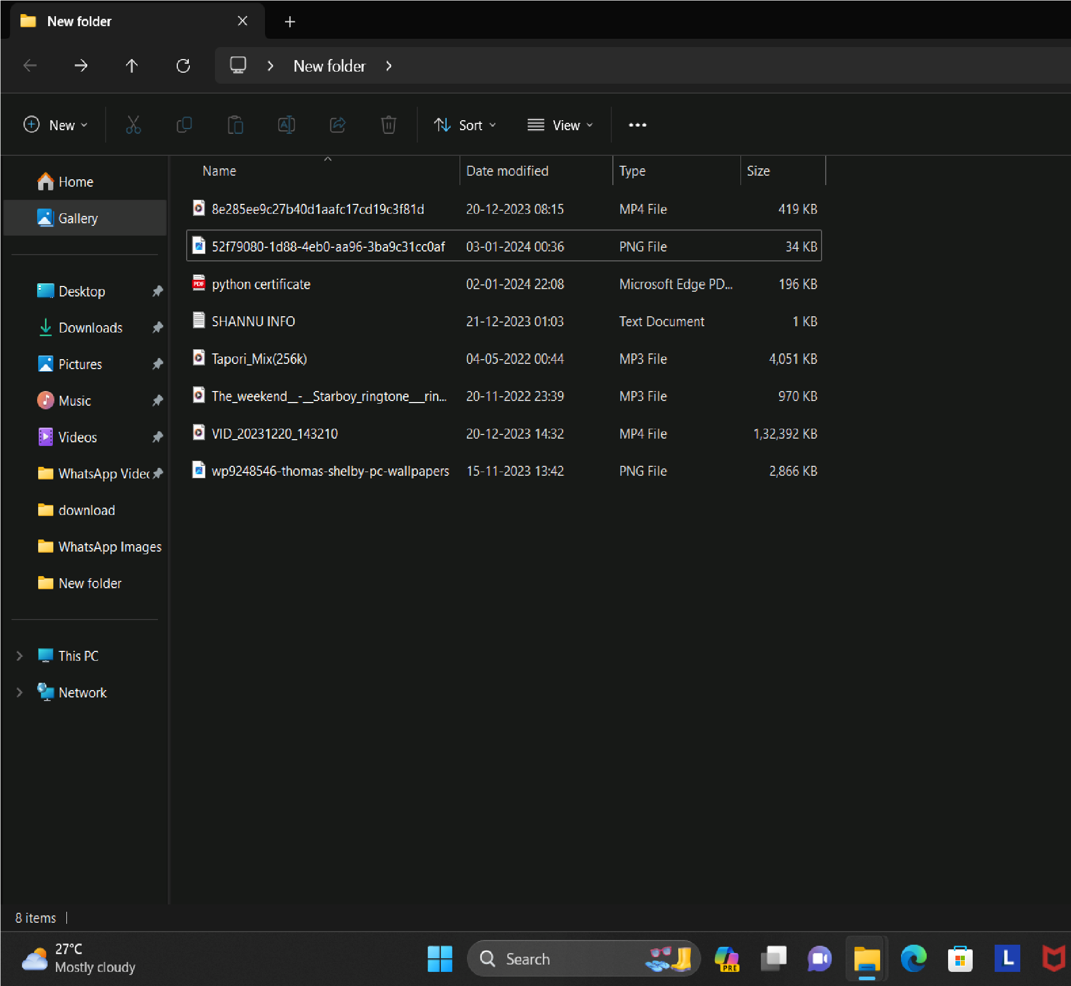

(Fig 9.2.1) Random unorganized junk files before using the Organizer

**After running the Python script to organize files:**

* **File Organization**: Files will be sorted into subdirectories based on their extensions.
* **Console Output:** The script may provide progress updates and confirmation messages.
* **Visual Verification:** Check the specified directory to visually confirm the organized file structure.
* **Error Messages:** If any errors occur, the script may output error messages to the console.

These outputs help confirm that the script has successfully organized files according to the defined criteria.

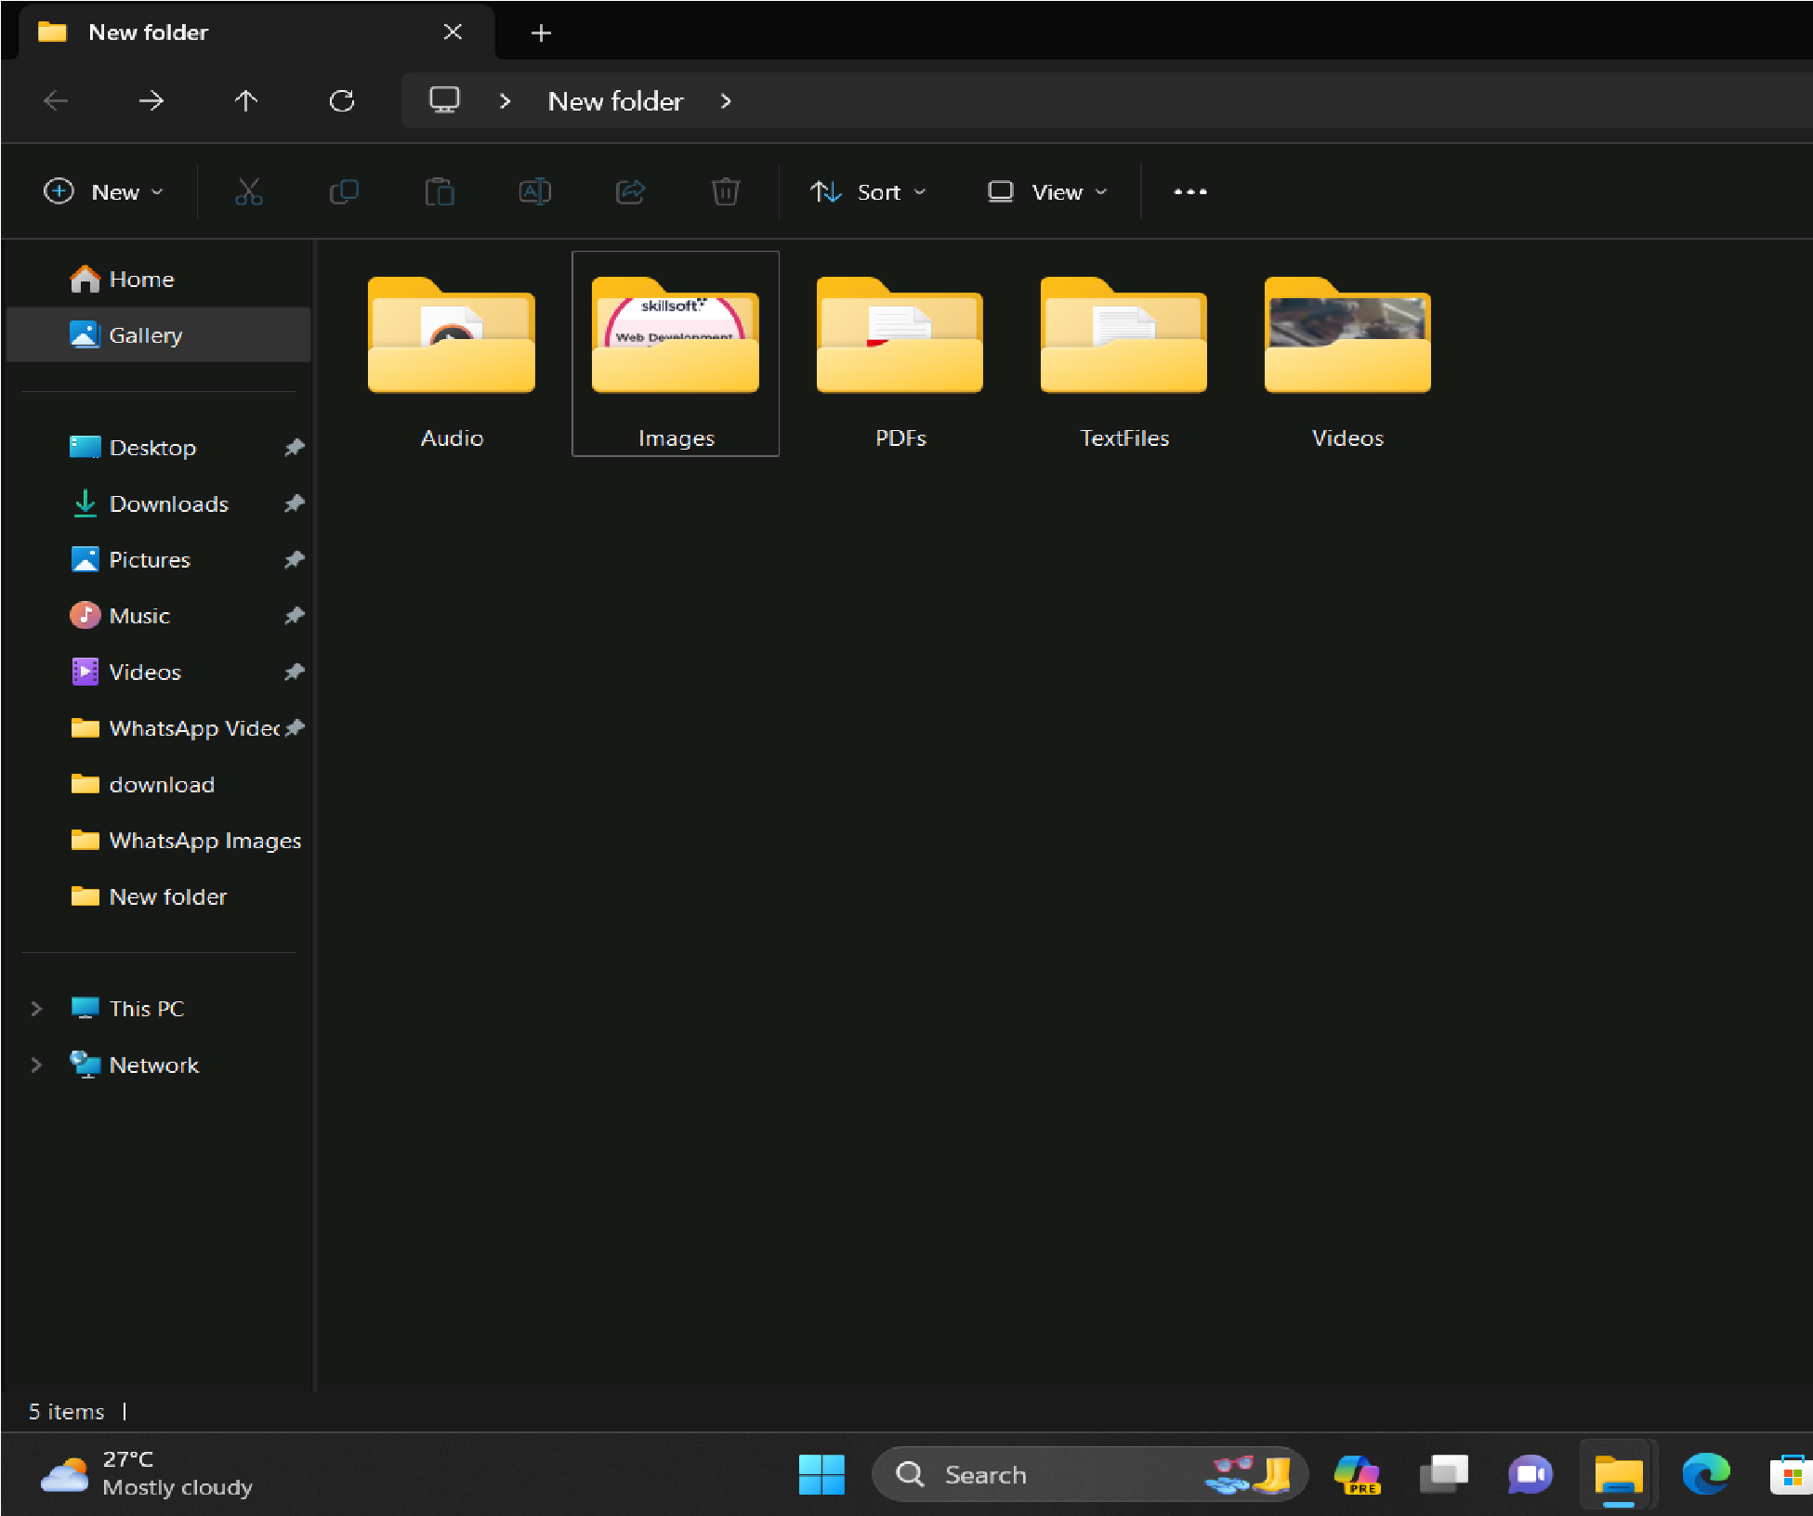

(Fig 9.2.2) Files after successfully running the organizer.

### 10. CONCLUSION

* In conclusion, the "Files Organizer using Python" project has successfully addressed the challenge of efficiently managing and organizing files within a designated directory. Through the development and implementation of a robust file organization algorithm, coupled with a user-friendly graphical interface, the project has provided users with an effective solution for streamlining their file management processes.
* One of the key achievements of the project is the automation of file organization tasks. By automatically sorting files into specific subdirectories based on their extensions, the program has significantly reduced the manual effort required for file management. This automation not only saves time but also minimizes the likelihood of errors that may occur during manual organization.
* Furthermore, the program's versatility and customization options have been well-received by users. The ability to define custom organization rules, exclude certain file types, and specify default directories adds flexibility and adaptability to the program, catering to the diverse needs of users across different contexts and scenarios.
* Throughout the development and testing phases, user feedback has played a crucial role in refining the program and ensuring its usability and effectiveness. By actively incorporating user suggestions and addressing areas for improvement, the project team has been able to enhance the overall user experience and functionality of the program.
* Looking ahead, there are several opportunities for future enhancement and expansion of the project. This includes optimizing the program's performance for handling larger volumes of files, integrating additional features such as support for cloud storage services, and enhancing the graphical interface to further improve user interaction and accessibility.
* Overall, the "Files Organizer using Python" project represents a significant step forward in simplifying file management processes for individuals and organizations alike. With its automated file organization capabilities, user-friendly interface, and potential for future growth, the project stands as a testament to the power of technology in addressing real-world challenges and improving productivity in the digital age.

### 11. FUTURE ENHANCEMENTS

The "Files Organizer using Python" project lays a solid foundation for efficient file management, and there are several avenues for future enhancements to further elevate its capabilities and user experience.

* **Cloud Storage Integration**:

Implement integration with popular cloud storage platforms such as Google Drive, Dropbox, or OneDrive. This enhancement would allow users to organize files seamlessly across both local and cloud storage, providing a unified file management solution.

* **Advanced File Categorization Algorithms:**

Explore and implement more advanced file categorization algorithms, such as machine learning-based approaches. This would enhance the accuracy of file type detection and organization, especially in cases where file extensions might not provide sufficient information.

* **Cross-Platform Compatibility:**

Enhance the program's compatibility to run on various operating systems, including Windows, macOS, and Linux. This would broaden the user base and make the tool accessible to a wider audience.

* **User-Defined Rules and Prioritization:**

Introduce a feature that allows users to define custom organization rules. Users could specify prioritization for certain file types, designate specific folders for particular extensions, or even create conditional rules based on file attributes.

* **Real-time Organization Dashboard:**

Develop a real-time dashboard within the graphical user interface that provides insights into the ongoing organization process. Users could monitor the progress, view statistics, and receive notifications for completed tasks.

* **File Versioning and Backup:**

Extend the functionality to support file versioning and backup options. Users could choose to keep track of multiple versions of files and create backups at specified intervals, adding an extra layer of data protection.

* **Multi-Language Support:**

Introduce multi-language support for the user interface to cater to a global audience. This enhancement would involve translating the interface into different languages, making it more accessible and user-friendly for non-English speakers.

### 12. REFERENCES

1. [Bernstein,](http://paperpile.com/b/m0tZjP/YzF2) [James.](http://paperpile.com/b/m0tZjP/YzF2) [2021.](http://paperpile.com/b/m0tZjP/YzF2) [*Windows*](http://paperpile.com/b/m0tZjP/YzF2)[*File*](http://paperpile.com/b/m0tZjP/YzF2)[*Management*](http://paperpile.com/b/m0tZjP/YzF2)[*Made*](http://paperpile.com/b/m0tZjP/YzF2)[*Easy:*](http://paperpile.com/b/m0tZjP/YzF2)[*Take*](http://paperpile.com/b/m0tZjP/YzF2)[*Control*](http://paperpile.com/b/m0tZjP/YzF2)[*of*](http://paperpile.com/b/m0tZjP/YzF2)[*Your*](http://paperpile.com/b/m0tZjP/YzF2)[*Files and*](http://paperpile.com/b/m0tZjP/YzF2)[*Folders*.](http://paperpile.com/b/m0tZjP/YzF2)
2. [Beuzen,](http://paperpile.com/b/m0tZjP/LLDc) [Tomas,](http://paperpile.com/b/m0tZjP/LLDc) [and](http://paperpile.com/b/m0tZjP/LLDc) [Tiffany-Anne](http://paperpile.com/b/m0tZjP/LLDc) [Timbers.](http://paperpile.com/b/m0tZjP/LLDc) [2022.](http://paperpile.com/b/m0tZjP/LLDc) [*Python*](http://paperpile.com/b/m0tZjP/LLDc)[*Packages*.](http://paperpile.com/b/m0tZjP/LLDc) [CRC](http://paperpile.com/b/m0tZjP/LLDc) [Press.](http://paperpile.com/b/m0tZjP/LLDc)
3. [Brownlee,](http://paperpile.com/b/m0tZjP/SPoc) [Jason.](http://paperpile.com/b/m0tZjP/SPoc) [n.d.](http://paperpile.com/b/m0tZjP/SPoc) [*Concurrent*](http://paperpile.com/b/m0tZjP/SPoc)[*File*](http://paperpile.com/b/m0tZjP/SPoc)[*I/O*](http://paperpile.com/b/m0tZjP/SPoc)[*in*](http://paperpile.com/b/m0tZjP/SPoc)[*Python:*](http://paperpile.com/b/m0tZjP/SPoc)[*Faster*](http://paperpile.com/b/m0tZjP/SPoc)[*File*](http://paperpile.com/b/m0tZjP/SPoc)[*I/O*](http://paperpile.com/b/m0tZjP/SPoc)[*With*](http://paperpile.com/b/m0tZjP/SPoc)[*Threads, Processes,*](http://paperpile.com/b/m0tZjP/SPoc)[*and*](http://paperpile.com/b/m0tZjP/SPoc)[*AsyncIO*.](http://paperpile.com/b/m0tZjP/SPoc) [SuperFastPython.com.](http://paperpile.com/b/m0tZjP/SPoc)

[4][Cannon,](http://paperpile.com/b/m0tZjP/zOEW) [Nicole](http://paperpile.com/b/m0tZjP/zOEW) [F.](http://paperpile.com/b/m0tZjP/zOEW) [2019.](http://paperpile.com/b/m0tZjP/zOEW) [*File*](http://paperpile.com/b/m0tZjP/zOEW)[*Management*](http://paperpile.com/b/m0tZjP/zOEW)[*Made*](http://paperpile.com/b/m0tZjP/zOEW)[*Easy:*](http://paperpile.com/b/m0tZjP/zOEW)[*Windows*](http://paperpile.com/b/m0tZjP/zOEW)[*Operating*](http://paperpile.com/b/m0tZjP/zOEW)[*System*.](http://paperpile.com/b/m0tZjP/zOEW) [WestBow](http://paperpile.com/b/m0tZjP/zOEW)

[Press.](http://paperpile.com/b/m0tZjP/zOEW)

1. [Gift,](http://paperpile.com/b/m0tZjP/AXJj) [Noah,](http://paperpile.com/b/m0tZjP/AXJj) [and](http://paperpile.com/b/m0tZjP/AXJj) [Jeremy](http://paperpile.com/b/m0tZjP/AXJj) [M.](http://paperpile.com/b/m0tZjP/AXJj) [Jones.](http://paperpile.com/b/m0tZjP/AXJj) [2008.](http://paperpile.com/b/m0tZjP/AXJj) [*Python*](http://paperpile.com/b/m0tZjP/AXJj)[*for*](http://paperpile.com/b/m0tZjP/AXJj)[*Unix*](http://paperpile.com/b/m0tZjP/AXJj)[*and*](http://paperpile.com/b/m0tZjP/AXJj)[*Linux*](http://paperpile.com/b/m0tZjP/AXJj)[*System*](http://paperpile.com/b/m0tZjP/AXJj)[*Administration*. O’Reilly](http://paperpile.com/b/m0tZjP/AXJj) [Germany.](http://paperpile.com/b/m0tZjP/AXJj)
2. [Gookin,](http://paperpile.com/b/m0tZjP/Din7) [Dan.](http://paperpile.com/b/m0tZjP/Din7) [2011.](http://paperpile.com/b/m0tZjP/Din7) [*PCs*](http://paperpile.com/b/m0tZjP/Din7)[*For*](http://paperpile.com/b/m0tZjP/Din7)[*Dummies*.](http://paperpile.com/b/m0tZjP/Din7) [John](http://paperpile.com/b/m0tZjP/Din7) [Wiley](http://paperpile.com/b/m0tZjP/Din7) [&](http://paperpile.com/b/m0tZjP/Din7) [Sons.](http://paperpile.com/b/m0tZjP/Din7)
3. [Masterson,](http://paperpile.com/b/m0tZjP/3cz5) [Charlie.](http://paperpile.com/b/m0tZjP/3cz5) [2017.](http://paperpile.com/b/m0tZjP/3cz5) [*Python:*](http://paperpile.com/b/m0tZjP/3cz5)[*Advanced*](http://paperpile.com/b/m0tZjP/3cz5)[*Guide*](http://paperpile.com/b/m0tZjP/3cz5)[*to*](http://paperpile.com/b/m0tZjP/3cz5)[*Programming*](http://paperpile.com/b/m0tZjP/3cz5)[*Code*](http://paperpile.com/b/m0tZjP/3cz5)[*with*](http://paperpile.com/b/m0tZjP/3cz5)[*Python*.](http://paperpile.com/b/m0tZjP/3cz5) [E.C. Publishing](http://paperpile.com/b/m0tZjP/3cz5) [via](http://paperpile.com/b/m0tZjP/3cz5) [PublishDrive.](http://paperpile.com/b/m0tZjP/3cz5)
4. [Slavio,](http://paperpile.com/b/m0tZjP/IlMq) [John.](http://paperpile.com/b/m0tZjP/IlMq) [2019.](http://paperpile.com/b/m0tZjP/IlMq) [*Python:*](http://paperpile.com/b/m0tZjP/IlMq)[*A*](http://paperpile.com/b/m0tZjP/IlMq)[*Beginners’*](http://paperpile.com/b/m0tZjP/IlMq)[*Guide*](http://paperpile.com/b/m0tZjP/IlMq)[*to*](http://paperpile.com/b/m0tZjP/IlMq)[*Python*](http://paperpile.com/b/m0tZjP/IlMq)[*Programming*](http://paperpile.com/b/m0tZjP/IlMq)[*to*](http://paperpile.com/b/m0tZjP/IlMq)[*Automate*](http://paperpile.com/b/m0tZjP/IlMq)[*the Boring*](http://paperpile.com/b/m0tZjP/IlMq)[*Tasks*](http://paperpile.com/b/m0tZjP/IlMq)[*and*](http://paperpile.com/b/m0tZjP/IlMq)[*Learn*](http://paperpile.com/b/m0tZjP/IlMq)[*Coding*](http://paperpile.com/b/m0tZjP/IlMq)[*Fast*.](http://paperpile.com/b/m0tZjP/IlMq)
5. [Sweigart,](http://paperpile.com/b/m0tZjP/RstU) [Al.](http://paperpile.com/b/m0tZjP/RstU) [2019.](http://paperpile.com/b/m0tZjP/RstU) [*Automate*](http://paperpile.com/b/m0tZjP/RstU)[*the*](http://paperpile.com/b/m0tZjP/RstU)[*Boring*](http://paperpile.com/b/m0tZjP/RstU)[*Stuff*](http://paperpile.com/b/m0tZjP/RstU)[*with*](http://paperpile.com/b/m0tZjP/RstU)[*Python,*](http://paperpile.com/b/m0tZjP/RstU)[*2nd*](http://paperpile.com/b/m0tZjP/RstU)[*Edition:*](http://paperpile.com/b/m0tZjP/RstU)[*Practical Programming*](http://paperpile.com/b/m0tZjP/RstU)[*for*](http://paperpile.com/b/m0tZjP/RstU)[*Total*](http://paperpile.com/b/m0tZjP/RstU)[*Beginners*.](http://paperpile.com/b/m0tZjP/RstU) [No](http://paperpile.com/b/m0tZjP/RstU) [Starch](http://paperpile.com/b/m0tZjP/RstU) [Press.](http://paperpile.com/b/m0tZjP/RstU)
6. [Yang,](http://paperpile.com/b/m0tZjP/NiTn) [Herong.](http://paperpile.com/b/m0tZjP/NiTn) [2008.](http://paperpile.com/b/m0tZjP/NiTn) [*Sorting*](http://paperpile.com/b/m0tZjP/NiTn)[*Algorithm*](http://paperpile.com/b/m0tZjP/NiTn)[*Tutorials*](http://paperpile.com/b/m0tZjP/NiTn)[*-*](http://paperpile.com/b/m0tZjP/NiTn)[*Herong’s*](http://paperpile.com/b/m0tZjP/NiTn)[*Tutorial*](http://paperpile.com/b/m0tZjP/NiTn)[*Examples*. HerongYang.com.](http://paperpile.com/b/m0tZjP/NiTn)

25